Assignment-6.3
TASK-01
# we are developing a simple student information management module.
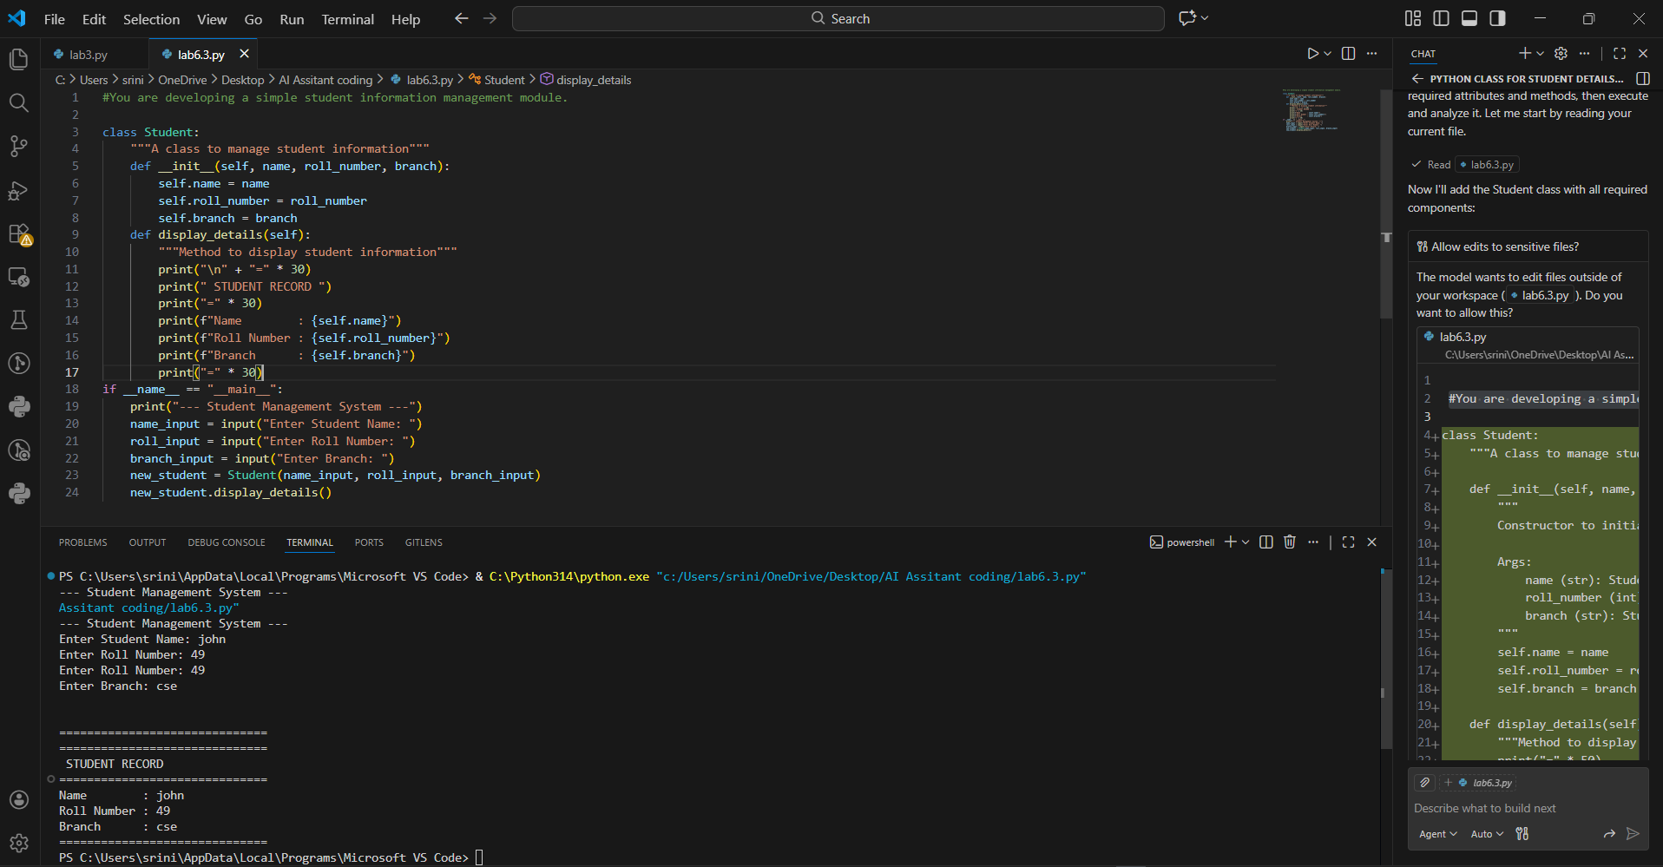
Research Analysis
From a research perspective, this code follows the "Don't Repeat Yourself" (DRY) principle. Instead of writing print statements for every student, the display_details method acts as a reusable tool, reducing the margin for error as the program grows.
TASK-02
# writing a utility function to display multiples of a given number.

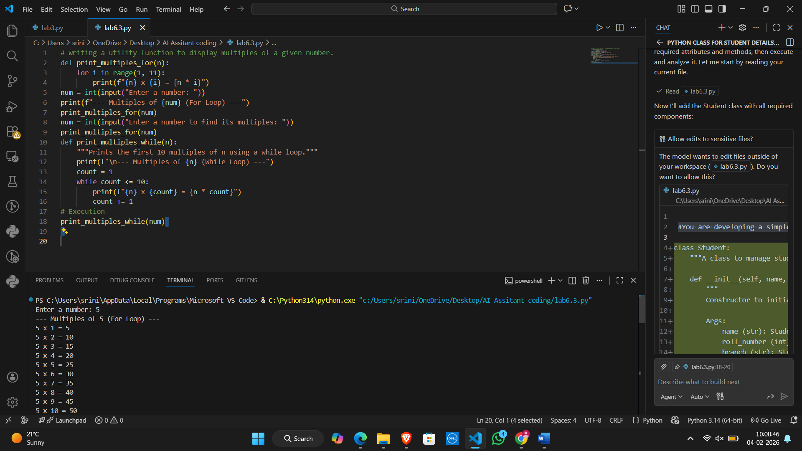
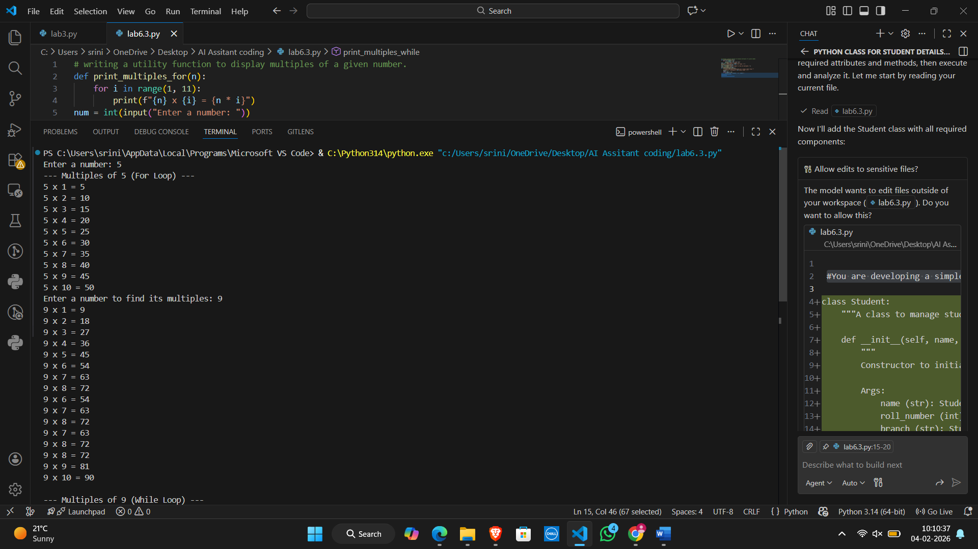
Research Analysis
• Input Validation: The code assumes the user will enter an integer. If a user types "seven," the program will crash with a ValueError.
• Type Hinting: In professional research-grade code, you would define the parameter type: def print_multiples_for(n: int):
TASK-03
#building a basic classification system based on age.

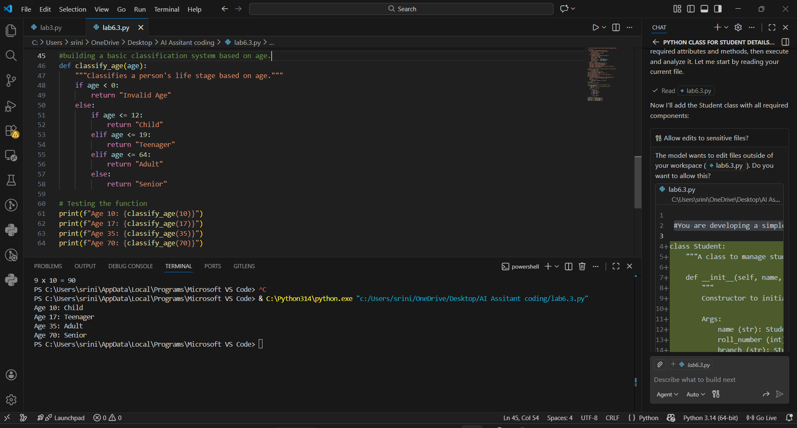
Research Analysis
• Readability vs. Robustness: For simple scripts, the flat if-elif is the most "Pythonic" (follows the Zen of Python principle: "Simple is better than complex").
• Structural Integrity: The use of a "Guard Clause" (checking if age < 0 first) is a professional best practice that prevents logic errors before they start.
• Performance: In modern Python (3.10+), the match-case statement has been introduced as a third alternative, providing even faster structural pattern matching for these types of classifications
TASK-04
# calculate the sum of the first n natural numbers.
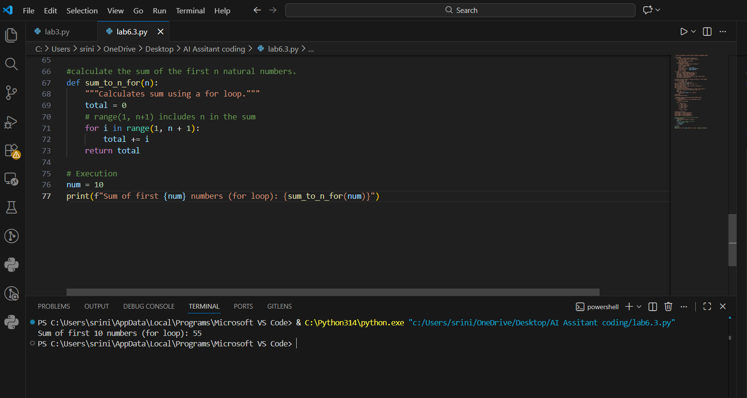
Research Analysis
While loops are excellent for teaching logic and control flow, the mathematical approach is the "gold standard" in software engineering for this specific problem because it bypasses the need for repetitive CPU cycles entirely.
#TASK-05
#designing a basic banking application.
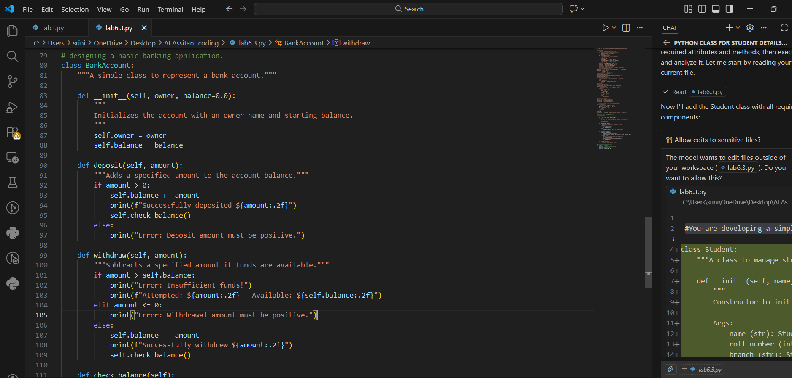
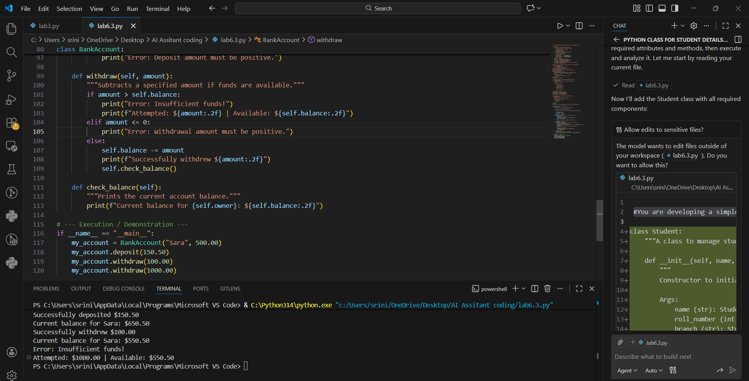
Research Analysis
. The Concept of "State"
The self.balance attribute represents the state of the object. Unlike a simple variable, this state is protected within the class instance. Every time you call deposit() or withdraw(), you are performing a "state transition."

